**Degree and Closeness Centrality:**

This is important to help find the important people in a network. Thinking about the karate group example, which of the 5 nodes are the most important?

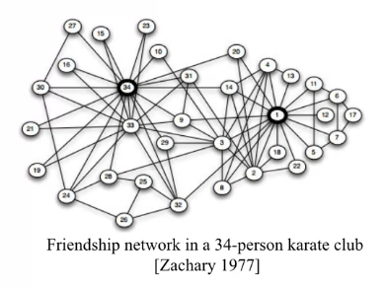

There are many ways to answer the question.

* Degree: number of friends. We would get nodes {34, 1, 33, 3, 2}
* Average proximity to other nodes: We get nodes {34, 1, 32, 9, 3}
* Fraction of shorted paths that pass-through node (important nodes tend to connect other nodes in the network). We get nodes {1, 34, 33, 3, 32}

**Network Centrality** allows us to find the most important nodes in a given network. E.g.

* Influential nodes in social media
* Nodes that disseminate information to many nodes or prevent epidemics.
* Hubs in a transportation network.
* Important pages on the Web.
* Nodes that prevent the network from breaking up.

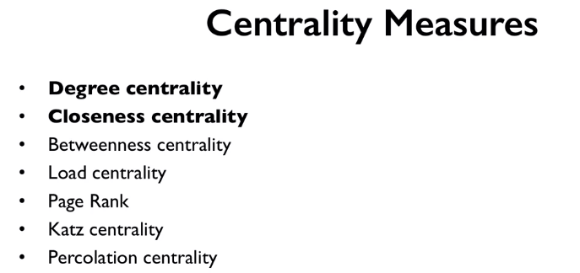

We will be taking close looks into the highlighted methods above

**Degree Centrality:**

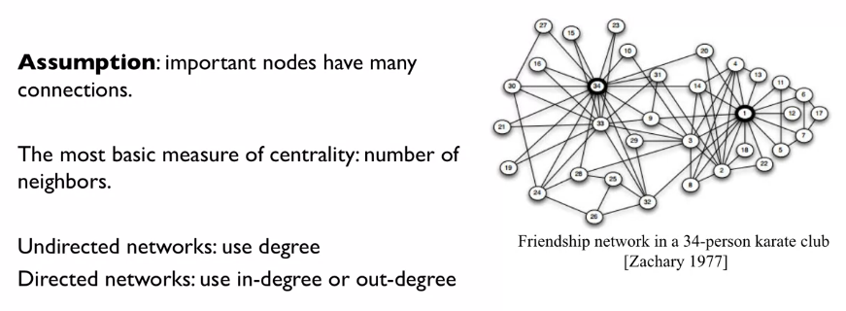

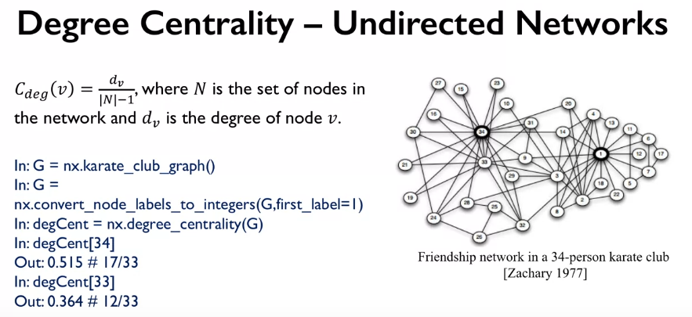

The Degree Centrality Cdeg is a range from 1-0, with 1 being a node connected to all other nodes, and 0 being a node connected to no other nodes.

For an undirected graph the degree becomes the in degree, so all the arrows pointing towards the nodes.

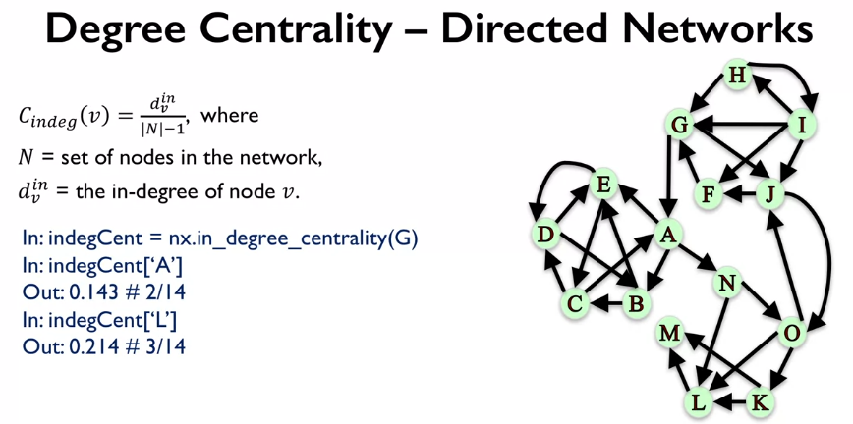

We could also look at the out degree of an undirected graph.

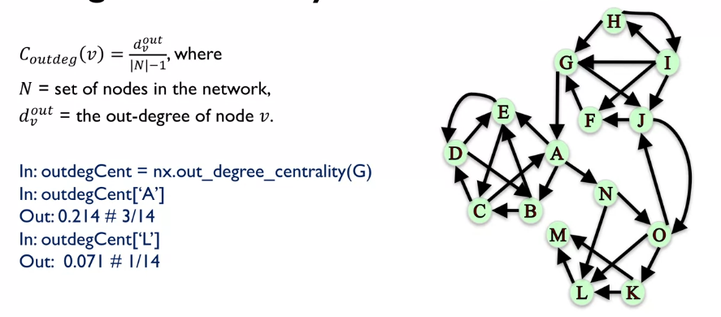

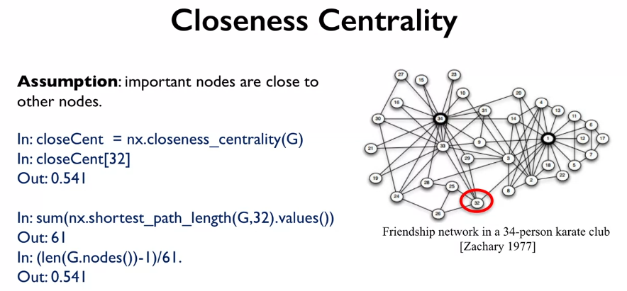

The maths behind **Closeness Centrality:**

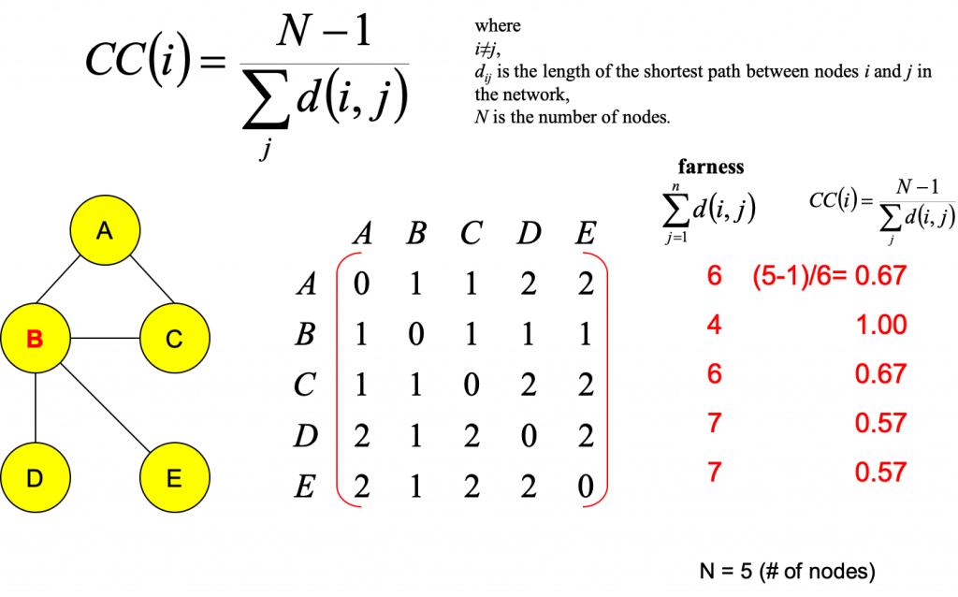

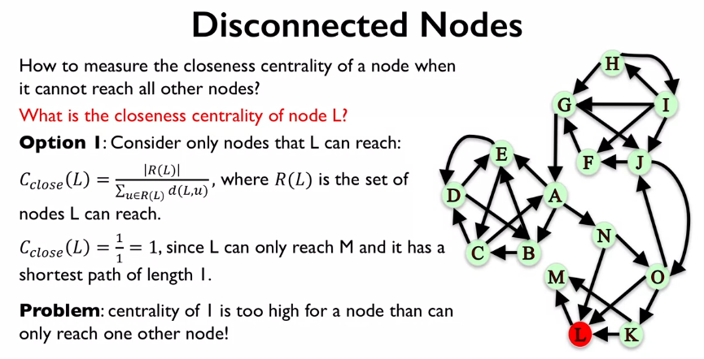

With disconnected nodes like L we can calculate the closeness by finding the subset of nodes that L can reach and then dividing it by the shortest distance between L and this subset of nodes. As we can see this causes problems as it returned a value of 1 for node L, which suggests that it’s very well connected…

We fix this by adding a normalized ratio to the above closeness equation:

